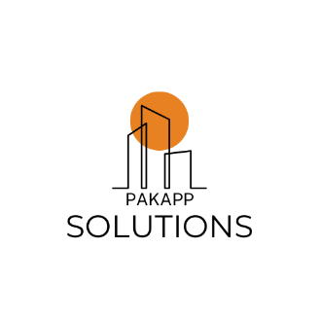
PAKAPP Solutions
BUSINESS PLAN
28/04/2025
Aroz Imran
Ammar Ahmad
Syed Sheraz
Hissamudin Hasaan
info@pakappssolutions.com
www.pakappssolutions.com

Executive Summary

Company Overview
- PakApps Solutions: A tech startup based in Lahore, PakApps Solutions develops and provides affordable custom mobile-oriented solutions that empower SMEs in Pakistan.
- Mission: To offer app development, maintenance, and consulting services that improve SMEs' visibility in the global audience and increase operational efficiencies.
- Target Market: With around 5 million SMEs in Pakistan, especially those in retail, hospitality, and services that demand low-cost digital solutions, PakApps aims at helping SMEs in need.

Unique Selling Proposition
- Local Expertise: We know very well what the market needs in Pakistan, and hence provide highly relevant solutions.
- Competitive Pricing: Not every bit as much as the customary IT companies, and much more overpriced than the overseas competitors.
- Localized Support: Ongoing customer support in order to facilitate satisfaction between the clients and the company itself.

Financial Projections
- Year 1 Revenue: PKR 10 million, scaling to PKR 25 million by Year 3.
- Break-even: Achieved within 18 months of operations.

Funding Strategy
- Funding Amount: PKR 5 million.
- Sources:
  - Personal: PKR 3 million from founders.
  - Angel investors: PKR 2 million.
- Use of Funds:
  - Talent acquisition: PKR 2.5 million.
  - Marketing: PKR 1.5 million.
  - Miscellaneous: PKR 1 million.
- Repayment: Investor funds are repayable within three years through revenues but may also have equity options for angel investors.
- Impact: Investment will catalyze the transformation of SMEs digitally and put PakApps ahead as the leader in the IT industry of Pakistan.

Investor Appeal
- Opportunity: One of the most interesting potentials in an IT system developing at the most rapid pace within Pakistan-it's growth should reach 20% per annum. (Pakistan Software Export Board, 2025).
- Goal: Provide investors hoping to profit from Pakistan's digitalization wave with substantial returns.

Company Description
Company Description: PakApps Solutions has been operating a Lahore-based tech start-up providing mobile application development services to Pakistani SMEs seeking affordable yet practical digital tools for their value-added-services.
Company History: Three tech entrepreneurs famous for their skills in the software development domain have come together to float this company in 2025.
Mission Statement: "To empower Pakistani SMEs with innovative and reasonably priced mobile app solutions that improve their business operations and customer engagement"
Vision Statement: " The company will establish itself as the top mobile application development provider focused on SMEs across Pakistan to lead digital transformations compared to other industries."
Products and Services: The company develops custom apps while maintaining these products and providing digital service advisory.
Potential Customers: The potential customer base consists of mainly Small and Medium Enterprises operating within retail, hospitality and service sectors yet the company does not have any sectoral restrictions.
Points of Differentiation: The company utilizes local market knowledge for its solutions and keeps prices accessible to customers alongside continuous customer service support.
Legal Status and Ownership: The founders, Aroz Imran, Ammar Ahmed, Syed Sheraz, and Hissamudin Hasaan, all own an equal share of the private limited company.
Key Partnerships: The company collaborates closely with SME associations, SMEDA, Local Universities, NUST Lahore and local tech incubators.
Potential Obstacles: The company faces competition from established companies besides retaining technical talent and winning market acceptance.
Countermeasures: Our countermeasures consist of affordable prices in combination with talent partner agreements alongside strategic business promotion methods.
Business Model Canvas (BMC):
- Key Partners: Tech incubators, universities, SME associations.
  - These partners are also a bridge to resources, mentoring, talent pipeline and networking opportunities that really count for scaling the operations and credibility within the local ecosystem.
- Key Activities: Marketing, client consultations, and app development.
  - Delivering top-notch apps, gaining insight into client needs through consultations, and advertising services to draw in new clients are the main activities.
- Key Resources: Cloud infrastructure, local market expertise, and skilled developers.
- Value Propositions: Customized, reasonably priced apps with regional support.
  - The particular supporting policies are comprehensible, affordable, and pertinent to small businesses, as they focus on increasing the comfort and deepening the relationship between the service provider and the beneficiaries in developing country settings - in short, under a certain type of circumstances.
- Customer Relationships: Personalized service, ongoing maintenance.
  - Building clientele relations by offering customized offerings and dependable services will guarantee the satisfaction of the client.
- Channels: Website, social media, industry events.
- Customer Segments: SMEs in urban and semi-urban Pakistan.
- Cost Structure: Salaries, software tools, marketing.
  - The core expenditures are providing fair compensation for skilled labor, acquiring development tools, and advertising a fated wave of growth.
- Revenue Streams: App development fees, maintenance contracts, consulting.
  - There are several resources from where the revenue are made, including non-recurring development fees, plus regular services of maintenance, consulting services etc.

Industry Analysis

Five Forces Model:
- Threat of New Entrants: Moderate. No doubt, the growing IT market in Pakistan really invites start-ups that could require technical skill and money. But we shall counter this by focusing on niche markets and bringing in local expertise.
- Bargaining Power of Suppliers: Low. A big pool of skilled technology professionals and beneficial open-source tools ensure that there is no dependency anymore.
- Bargaining Power of Buyers: High. Prices in SMEs become noticeable, as there is a whole plethora of choices that may compete against us; but then will come the differentiation stemming from value added services.
- Threat of Substitutes: Moderate. This can result from the slight charge in grammatical term plan, changes in the style guide for instance.
- Competitive Rivalry: High. The domain features local firms like Systems Limited which return to the sphere, tells the story.shortcode system to move beyond the mere tale of ordinary clients.
- Industry Size and Growth: According to the Pakistan Software Export Board (2025), the country's IT sector is worth $2.63 billion and is expanding at a rate of 7.4% per year as a result of exports and digital adoption.
- Industry Structure: Fragmented. There are large players working for the corporate sector and others focused on SMEs in the capital market
- Nature of Participants: some freelance workers, some established companies, and mostly local startups.
- Key Success Factors: quality, price, and client service.
- Industry Trends: Higher demand for cloud computing, AI integrations, and mobile applications.
- Long-term Prospects: Good, supported by initiatives such as Digital Pakistan.

Market Analysis

Target Market: The target market consists of SMEs in Pakistan with a total number of 5 million businesses according to SMEDA's statistics and the main locations of focus will be the cities of Karachi, Lahore, and Islamabad.
Market Segmentation: retail industry alongside hospitality and services sector with micro to medium business types and evaluation of technological preparedness.
Buyer Behavior: Cost is an important priority for SMEs
Competitor Analysis:
- Direct Competitors: Local firms like NetSol.
- Indirect Competitors: Global DIY platforms such as Wix, freelancers, Upwork
- Competitive Edge: Custom-built solutions tailored to clientele operating at less than the cost large firms charge and giving more support than freelancers.
SWOT Analysis:
- Strengths: Indigenous expertise, affordable prices.
- Weaknesses: Less brand recognition, small team.
- Opportunities: SME digitalization, government support.
- Threats: Formidable competition, fast tech changes.

Marketing Plan

Product: Custom mobile apps with features like e-commerce, analytics, and customer management.
Price: Tiered pricing between PKR 50,000 and 150,000 per app along with monthly maintenance fees at PKR 10,000.
Place: Provide mobile application services through an online distribution system to urban small and medium enterprises using website and cloud technology.
Promotion: As an initial approach the company will provide free basic features through a freemium model to recruit early users of the apps.
The initial free price allows SMEs to overcome their barriers while rapidly developing their adoption so they can establish an audience base.
Marketing Tactics:
The company should capitalize on happy SME clients by letting them serve as marketing ambassadors who generate new prospects through referral programs as well as providing endorsements. The reason behind this approach is that it enables organic trust creation through leveraging networks of SME businesses.
Social Media: Post success stories, client testimonials, and app showcases on platforms like LinkedIn, Facebook, and Instagram. Using this marketing method extends the reach while offering real outcomes that generate interest from new customers.
- Overall Strategy: Our company aims to become the primary economical choice for application services targeted at small to medium-sized enterprises.
- Sales Process: Consultation and Advances through Proposal and Development Stage Pursued by Testing and Infrastructure Deployment and Ends with Support Activities for Customers.
- Sales Tactics: The first meeting comes free of charge while existing clients get rebates from referrals.
- Market Changes: The growing adoption of mobile technology and potential governmental legislative changes that would boost customer demand.

Product (or Service) Design and Development Plan
- Development Status: Prototypes for e-commerce are given.
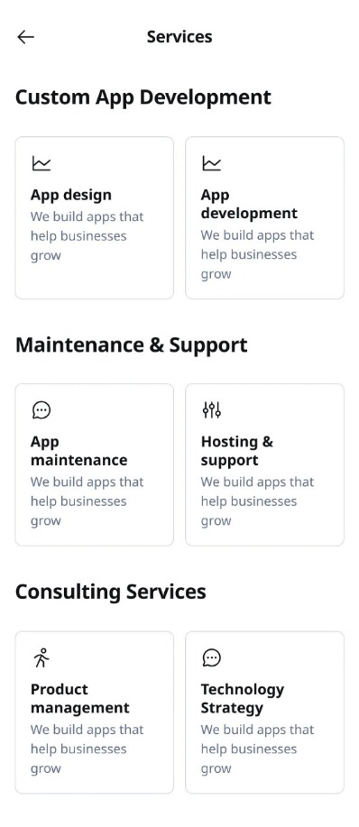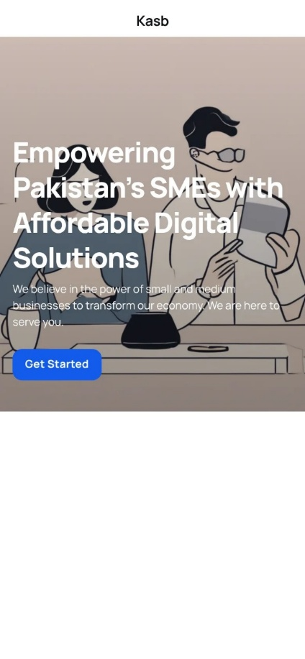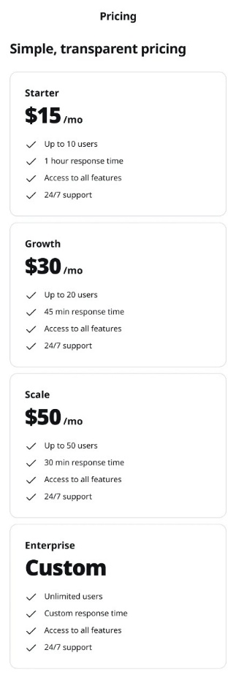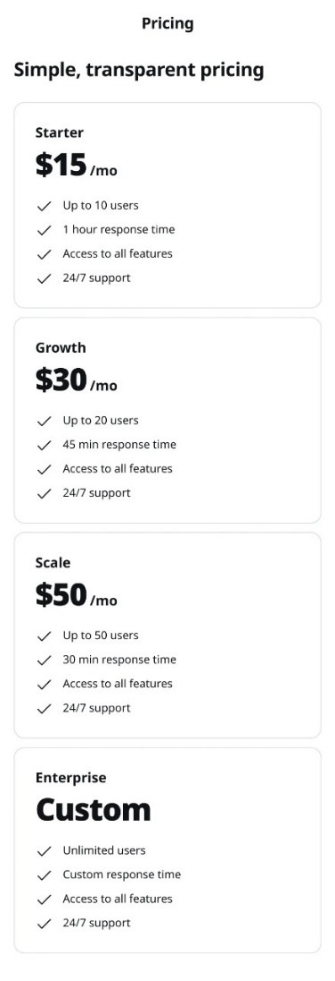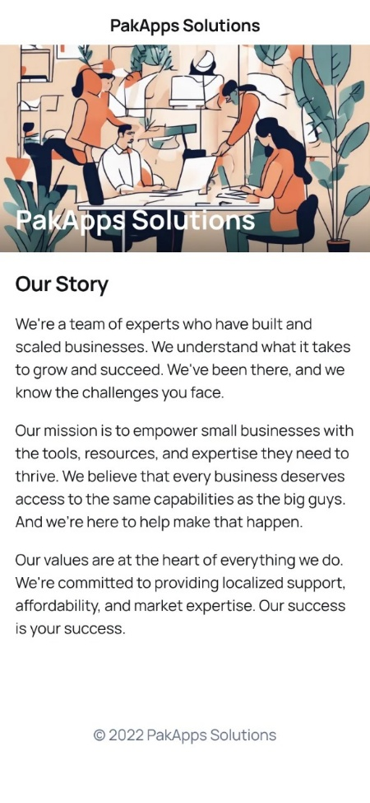
- The project faces technical difficulties alongside data security risks and requires meeting client demand.
- Solutions: Agile methodology, encryption, consistently client feedback.
- The total budget estimation amounts to PKR 2 million for tool purchases along with staff expenses and test implementation.
- The business holds trademark rights for "PakApps Solutions" with its app products maintaining compliance with intellectual property legislation.
- Open-source tools serve as the materials for sourcing to decrease operational expenses.
- The development project takes place in Lahore where the city utilizes its technological workforce.

Management Team and Company Structure

Management Team:
- Aroz Imran (CEO): With 10 years in software development, Imran ensures technical excellence and innovation in app solutions, driving the company’s product vision.
- Sheraz Hussain (COO): Sheraz’s 8 years in project management streamline operations, ensuring timely delivery and efficient resource allocation.
- Ammar Ahmed (CMO): After seven years in digital marketing, Ammar will acquire customers while developing brands through SME-centric campaigns.
Board of Advisors:
- Hissamuddin Hassan: the eminent academic in IT and entrepreneurship, specifies insights regarding the industry's trends and prospects of joint academic efforts.
- Mr. Faisal Ahmed: Former CTO of one of the giants from the leading Pakistani IT firms, provides directions regarding strategic measures about scaling technology operations.
- Ms. Nadia Tariq: SME consultant with SMEDA, rendering advice on market needs and government initiatives.
To add value, the BoA brings their long experience in the industry to the strategy of decision-making and in developing credibility.
Key Personnel:
- UI/UX Designers: The inner working of the app will be intuitive and easily understood and navigated by the end customer (SMEs) using them.
- Backend Developers: Will scale and design the infrastructure upon which apps are built. That is critical because SMEs would use that platform for personal and business transactions and data storage.
They have the skills to develop quality customized apps that can also satisfy the local market demands, differentiating PakApps from others offering generic products.
Company Structure:
- A flat hierarchy with clearly defined roles into development, sales, and support- fuels agility and rapid communication.
Skills Profile:
- Current Strengths: leadership in software the CEO, Operations the COO, and marketing the CMO.
- Vacancies: UI/UX designers and developers to be hired within 6 months via job portals and university partnerships.
The CEO’s technical leadership guarantees product excellence, the COO’s operational skills optimize costs, and the CMO’s marketing expertise boosts client growth - forming a solid foundation for PakApps success.

Operation Plan

General Operations: Agile development methods combined with client updates and quality assurance tasks.
Location: Lahore, Gulberg
Facilities and Equipment:
Facility/Equipment | Operational Benefit
Office Space | The office serves as an essential center where employees collaborate and meet clients to conduct operational tasks that boost production efficiency.
Computers | Computers serve as the fundamental elements to develop applications along with designing them and conducting tests and handling administrative tasks which enables the smooth implementation of critical business functions.
Software Licenses | Software Licenses enable staff members to obtain necessary development tools through which they can create standard-quality apps on site.
Cloud Infrastructure | PakApps benefits from Cloud Infrastructure that allows scaled application deployment which provides secure data storage and effortless file updates enabling the company to serve customer needs with enhanced performance.
The benefits include employee access to qualified personnel and close geographical proximity to customer bases.

Financial Projections

- Revenue Drivers and Profit Margins
  - Revenue Drivers:
    - App development fees pricing: PKR 50,000–150,000 per application.
    - Maintenance fees PKR 10,000/month per client.
    - Digital consulting services hourly.
  - Profit Margins:
    - Development: 40% margin.
    - Maintenance: 60% margin.
    - Consulting: 50% margin.
- Fixed and Variable Costs
  - Fixed Costs:
    - Salaries: PKR 3,600,000/year.
    - Rent: PKR 600,000/year.
    - Marketing: PKR 500,000/year.
    - Depreciation: PKR 50,000/year.
    - Total Fixed Costs: PKR 4,750,000/year.
  - Variable Costs:
    - Direct costs for app development for software licenses and cloud services PKR 40,000 per project.
    - Maintenance and consulting costs: Labor, included in fixed salaries.
- Operating Leverage and Its Implications
  - Operating Leverage: high ratio of fixed versus variable costs so that once an enterprise has covered its fixed costs, revenue accruing therefrom adds significantly to profits.
  - Implications: Growth of sales beyond the break-even point of 80 projects brings with it rapid growth in profit. However, the firm will incur higher initial losses in cases of slow sales.
- Break-even Chart and Calculations
  - Break-even Point:
    - Selling Price per Project: PKR 100,000 (average).
    - Variable Cost per Project: PKR 40,000.
    - Contribution Margin: PKR 60,000 per project.
    - Break-even Projects: Fixed Costs ÷ Contribution Margin = 4,750,000 ÷ 60,000 ≈ 79.17, or 80 projects.
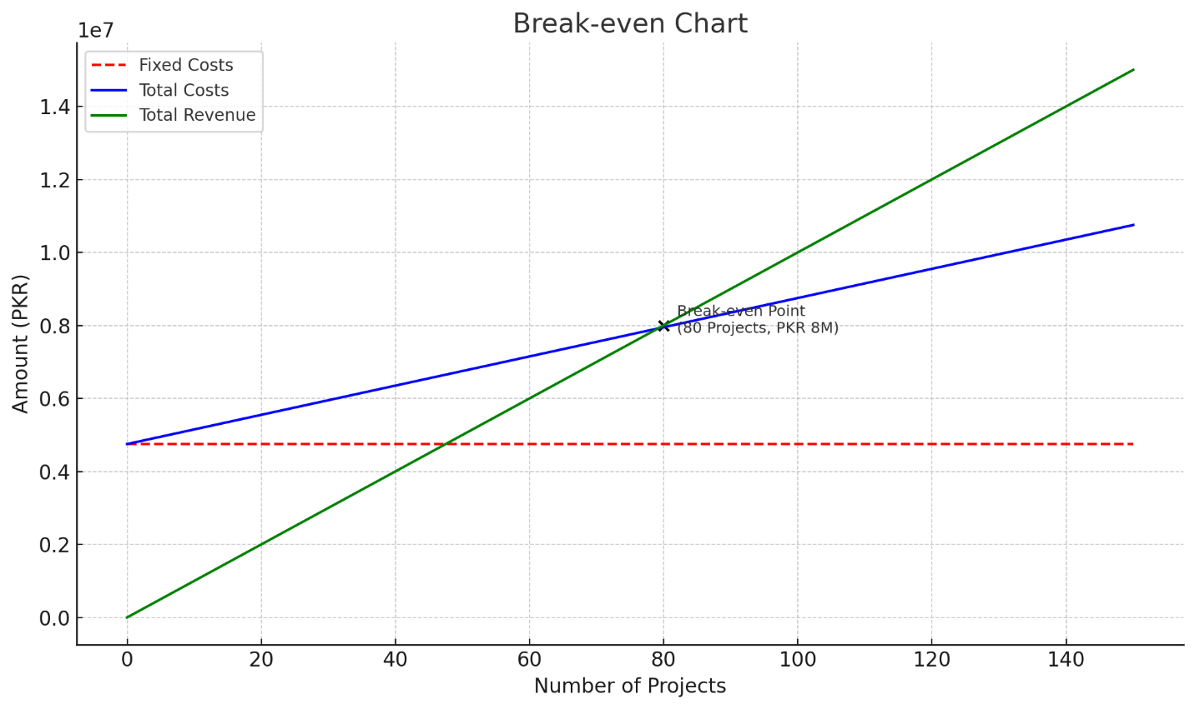
  - Break-even Chart Description:
    - Fixed Costs Line: Horizontal at PKR 4,750,000.
    - Total Cost Line: Starts at PKR 4,750,000, increases by PKR 40,000 per project.
    - Total Revenue Line: Starts at 0, increases by PKR 100,000 per project.
    - Break-even Point: Intersection at 80 projects (PKR 8,000,000 revenue).
- Determine the Start-up Cash Needed (and Where the Cash Would Be Utilized for Efficiency)
  - Start-up Cash: PKR 5,000,000.
  - Utilization:
    - Office setup: PKR 1,000,000 in rent and equipment.
    - Talent acquisition: PKR 2,500,000 in initial salaries.
    - Marketing: PKR 1,000,000 in campaigns and events.
    - Miscellaneous: PKR 500,000 in software, contingencies.
- Discuss the Sources of Funds
  - Founders’ Funds: PKR 3,000,000 in personal savings.
  - Angel Investor: PKR 2,000,000 to be repaid within 3 years.
- Forecast/Project Your Expected Sales Over the Next Few Years
  - Year 1: PKR 10,000,000 100 projects.
  - Year 2: PKR 15,000,000 150 projects.
  - Year 3: PKR 25,000,000 250 projects.
Growth driven by SME digitalization, marketing efforts, and referrals.
- Analyze the Financial Performance of Competitors to Forecast Your Own Expected Performance
  - Local Competitors TechAbout: Revenue growth of 15-20% annually, with profit margins around 30%.
  - PakApps Forecast:
    - Year 1: 10.5% profit margin (PKR 1,050,000 on PKR 10,000,000).
    - Year 3: 15% margin (projected), aligning with industry norms as operations scale.

Overall Schedule

Milestones:
- Month 1: Incorporate PakApps Solutions.
- Month 3: Complete prototypes.
- Month 4: Secure first 5 clients.
- Month 6: Achieve PKR 1 million revenue.

